Rochester Black Personhood
www.AmINotAChild.com
WARNING: WE FACE EXTINCTION
Monroe County’s black community in is on the path to extinction. Our population meets IUCN criteria for an endangered species.
There are currently over 113,000 black people in Monroe County. If current trends continue, that population will be cut in half by the time our grandchildren retire—as early as 60 years from now.,
We are no longer replacing ourselves. In just the last ten years black fertility rates have dropped by over 20%, from 2.48 children per woman to just 1.96 children per woman. Replacement rate is 2.1.
More than 1 in 3 black children are missing from our families due to abortion: 36% of black pregnancies end in abortion.³
Racial and ethnic minorities represent 24% of females 15-44 years old, but have 65% of the abortions.³

WE DEMAND PERSONHOOD
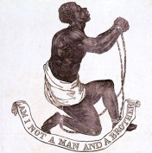
A person is an organism with unique human DNA governing his or her own maturation from conception to natural death. Every person bears the image of God. Any person, therefore, demands our utmost dignity, respect, and protection—man, woman, boy and girl—from the womb to the tomb.
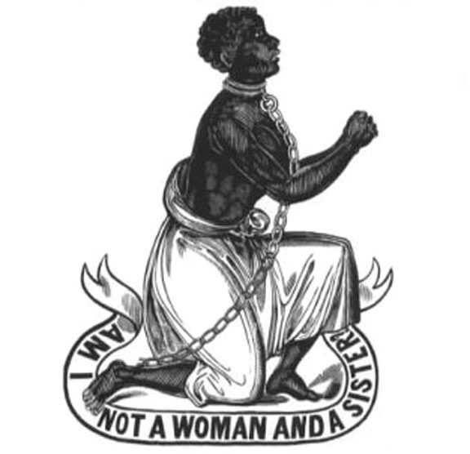
In 1787 we asked, “AM I NOT A MAN AND A BROTHER?” and we overcame.
In 1837 we asked, “AM I NOT A WOMAN AND A SISTER?” and we were victors.
The time has come for us to raise our voice
for the future of our people:
“AM I NOT A CHILD, AND A SON, AND A DAUGHTER?”
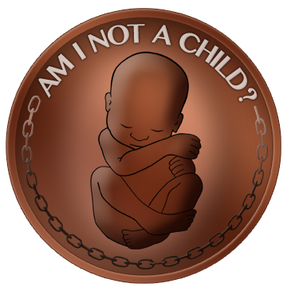

The International Union for Conservation of Nature (2009). IUCN Red List Criteria for Endangered. Available from http://www.eoearth.org/article/IUCN_Red_List_Criteria_for_Endangered
Population projections performed using fertility rate trends and U.S. Census Bureau methodology (see footnote 4).
Vital Statistics of New York State – 2010. Available from http://www.health.ny.gov/statistics/vital_statistics/2010/
Total fertility rates calculated from U.S. Census Bureau Vintage 2011 Population Estimates, applying NCHS methodology. See http://www.census.gov/population/projections/files/methodology/methodstatement12.pdf

